1. Look at this CV. What hard and soft skills does this person have?
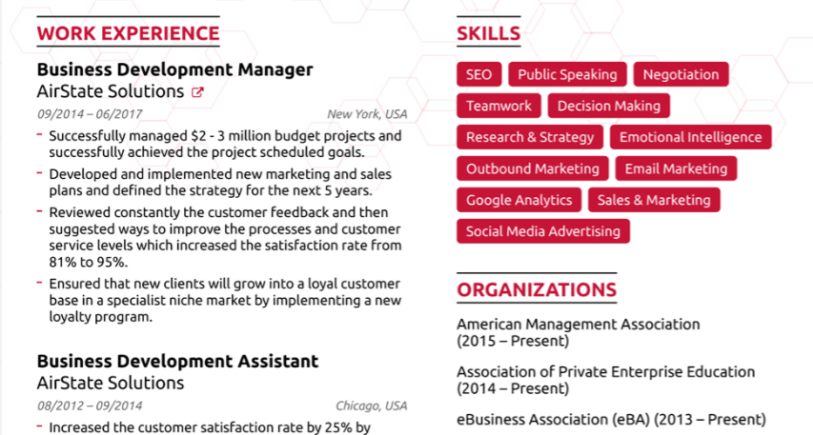

Write down soft and hard skills from the CV.
Hard skills | Soft skills

2. Find soft and hard skills in this CV extract.
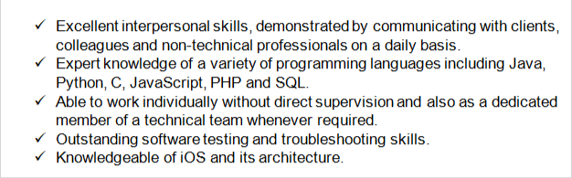

Hard skills | Soft skills

3. Match the skill to the definition
- Decision Making | - the process of two or more people, or companies working together to complete a task or achieve a goal
- Listening Skills | b) the process of deciding about something important, especially in a group of people or in an organization.
- Collaboration | c) feeling sure of yourself and your abilities — not in an arrogant way, but in a realistic, secure way.
- Confidence | d) the process of organizing and planning how to divide your time between different activities.
- Problem-solving | e) presentation that is given live before an audience.
6. Time management | f) giving your task or responsibility to another person, typically one who is less senior than you.
7. Delegation | g) the process of identifying, assessing, and controlling threats to projects, companies, or team.
8. Risk Management | h) Listening is the ability to accurately receive and interpret messages in the communication process.
9. Public Speaking | i) the act of defining a problem; determining the cause of the problem; identifying, prioritizing, and selecting alternatives for a solution; and implementing a solution.
10. Negotiation | j) skill that allows two or more sides to reach a compromise. These are often soft skills such as communication, persuasion, planning, and cooperation.

1 -
2-
3-
4-
5-
6-
7-
8-
9-
10-
4. Divide soft skills in the box into 3 categories. One skill can be used more than once.

Decision Making
Risk Management
Delegation
Public Speaking
Listening Skills
Confidence
Collaboration
Problem-solving
Time management

Communication Skills | Teamwork Skills | Leadership skills

Do you have any of the mentioned skills? What are they?

5. Match the halves to create different skills.

- being a team | - speaker
- risk | b) player
- good public | c) solving
- problem | d) making
- decision | e) management
1
2
3
4
5

6. Read how people describe their co-workers. Write their soft skills (can be more than 1)

Name | Soft skill
John always takes responsibility for the team. We can always rely on him. | reliability, ….
It's very comfortable to work with Sarah in one team. She always listens and helps.
Peter can work alone on every task and he does a good job.
Natasha is very good with customers. She can always ask them to make the price better and they agree.
Antony gives wonderful presentations. We always send him to present our products to the clients
Even when Tim has a lot of tasks he still manages to do everything on time and in good quality.

7. Put the missing words into the sentences and complete the sentence with the skills.

- John always……… responsibility for the team. We can always ……. on him. John is responsible (example)
- It's very comfortable to……..with Sarah in one team. She always…….. and helps. Sarah is…..
- Peter can work alone on every task and he……..a good job. Peter is…..
- Natasha is very good ……customers. She can always ask them to make the price better and they agree. Natasha is a good…..
- Antony gives wonderful presentations. We always send him to ……. our products to the clients. Anthony is a good…..
- Even when Tim has a lot of tasks he still manages to do everything ….. time and in good quality. Tim is a great …..

8. Put the words and phrases from the box into the right column (one word can be used in more than 1 column).
PHP
Creative
Teamwork
a good listener
Communication
a fast learner
Public speaking
JS
Independent
Databases
Delegation
Responsible
Time management
a great public speaker
Listening

I am | I have experience with | I am good at

9. Use vocabulary and expressions from this lesson and write your skills into this table.

I am | I have experience with | I am good at

Watch a video about skills!
Top Resume Skills

